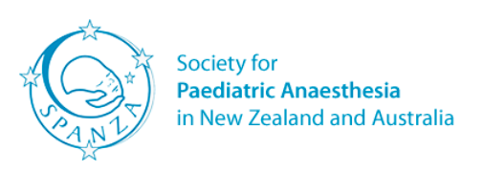 | Sponsored Overseas Delegate  Application Form
If possible, please use a computer to type answers. If writing, please use CAPITAL letters.
First (given) name: |  | Last (family) name:
Age: |  | Gender:  Male / Female
Telephone numbers:  Give country code / number  Mobile:  Work:  Home: |  | Email:
 |  | Fax: Give country code / number
 |  | Nationality:
Current job title:

Hospital / institution where you work: Please include address

Basic medical training:
Name of medical school / Name of degree / Number of years of training / Year of completion

Anaesthesiology training:
Name of programme or institution / Name of qualification / Number of years of training / Year of completion

Please describe your hospital (in less than 100 words).

Please describe your job (in less than 100 words).

Why should a scholarship be awarded to you (in less than 100 words)?

What was the last anaesthesiology conference you attended?

